**Driver:**

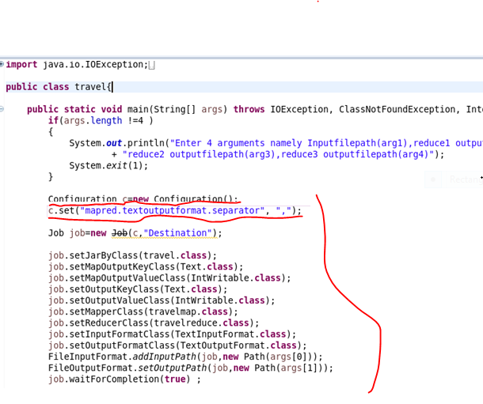

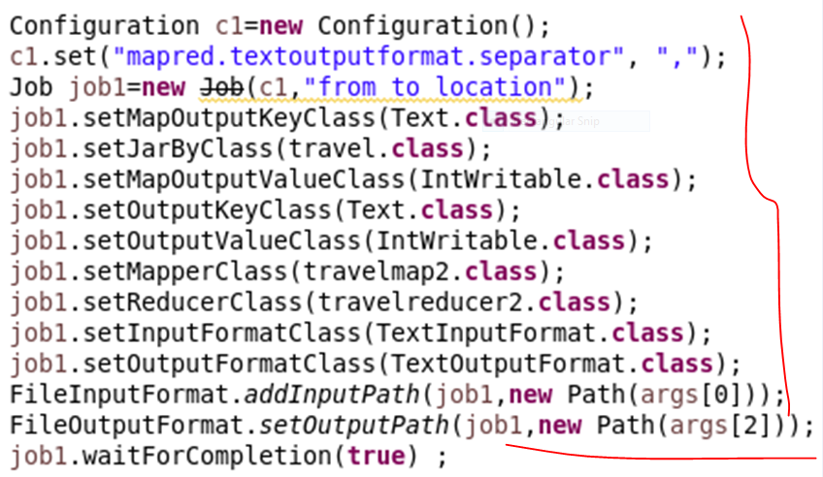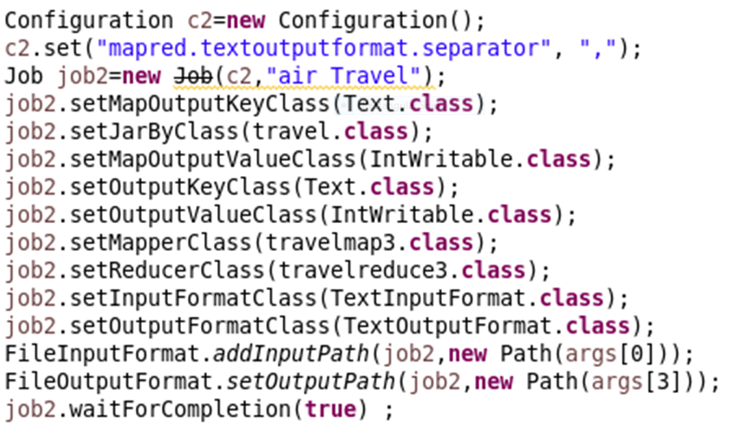

**Find out how many people has chosen their destination as MIA and MCO:**

**Mapper:**

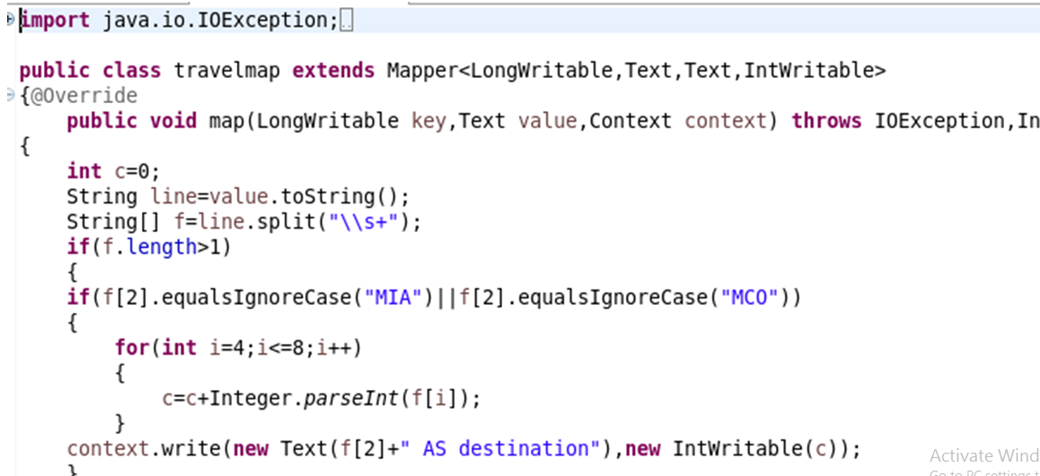

**Reducer:**

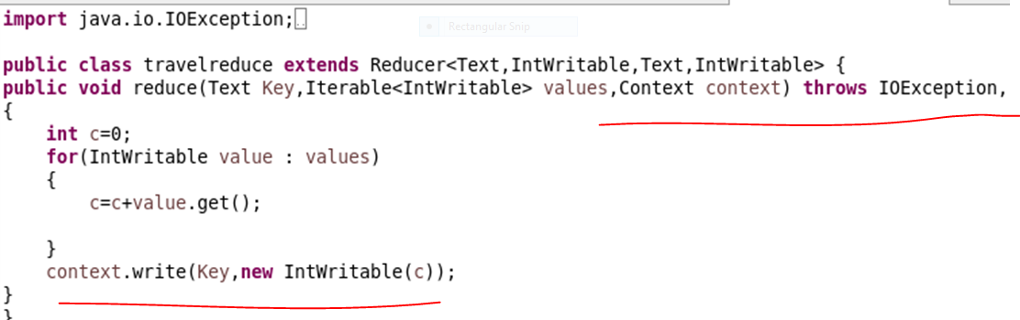

**Find out the number of people undertaken the trips from the places MIA and HOU:**

**Mapper:**

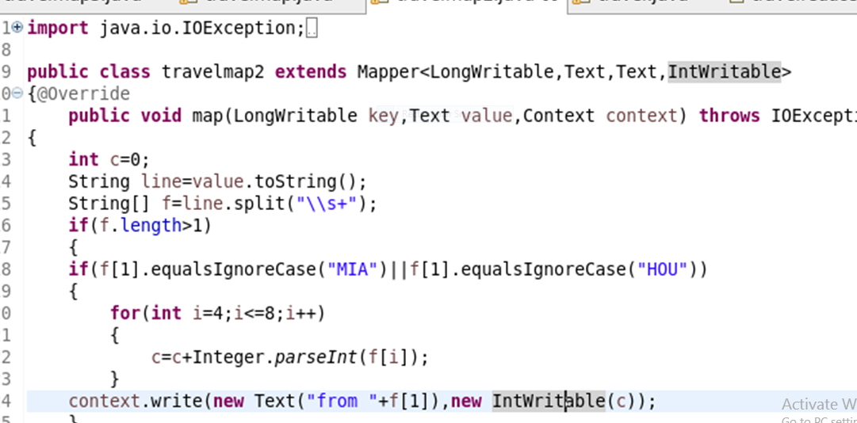

**Reducer:**

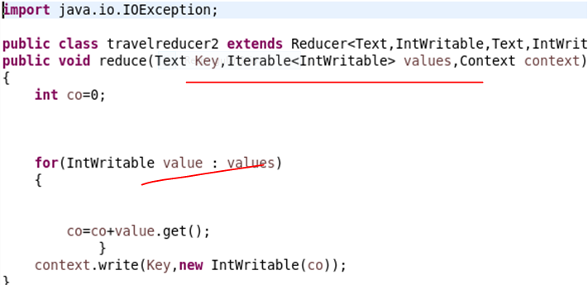

**Find out how many people has chosen airline mode of travel for the places LAS and LAX:**

**Mapper:**

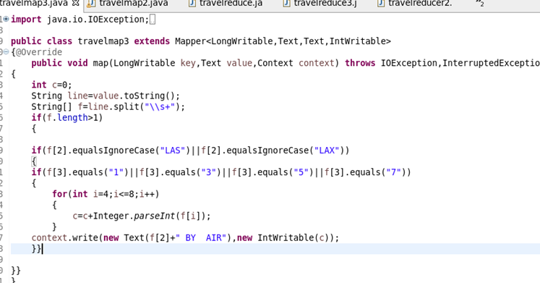

**Reducer:**

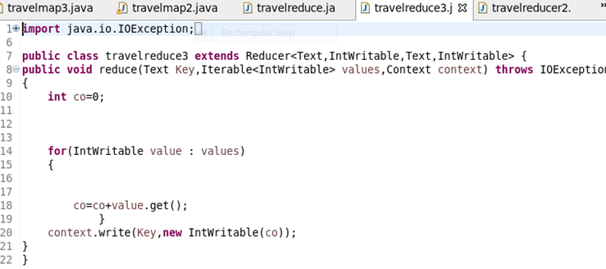

**Output:**

